Trace Stewart

CPE301 – SPRING 2018

Design Assignment 2

**DO NOT REMOVE THIS PAGE DURING SUBMISSION:**

The student understands that all required components should be submitted in complete for grading of this assignment.

|  |  |  |  |
| --- | --- | --- | --- |
| **NO** | **SUBMISSION ITEM** | **COMPLETED (Y/N)** | **MARKS**  **(/MAX)** |
| 1 | COMPONENTS LIST AND CONNECTION BLOCK DIAGRAM w/ PINS |  |  |
| 2. | INITIAL CODE OF TASK 1/A |  |  |
| 3. | INCREMENTAL / DIFFERENTIAL CODE OF TASK 2/B |  |  |
| 3. | INCREMENTAL / DIFFERENTIAL CODE OF TASK 3/C |  |  |
| 3. | INCREMENTAL / DIFFERENTIAL CODE OF TASK 4/D |  |  |
| 3. | INCREMENTAL / DIFFERENTIAL CODE OF TASK 5/E |  |  |
| 4. | SCHEMATICS |  |  |
| 5. | SCREENSHOTS OF EACH TASK OUTPUT |  |  |
| 5. | SCREENSHOT OF EACH DEMO |  |  |
| 6. | VIDEO LINKS OF EACH DEMO |  |  |
| 7. | GOOGLECODE LINK OF THE DA |  |  |
|  |  |  |  |
|  |  |  |  |

1. **COMPONENTS LIST AND CONNECTION BLOCK DIAGRAM w/ PINS**

The components used for this project were the atmega xplained mini, a solderless breadboard, and LED, a push button, and some wires.

Block diagram with pins used in the Atmega328P

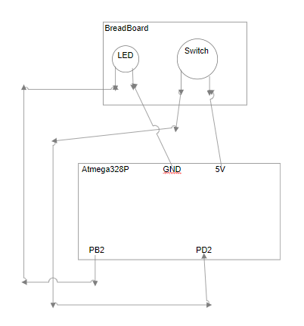

1. **INITIAL/DEVELOPED CODE OF TASK 1**

**Assembly Code**

; DA2_1.asm

;

; Created: 3/6/2018 10:12:34 AM

; Author : trace

start:

; constant declaration (value & register)

.EQU LOOPCNT = 244 ; loop count for timer

CLR R0 ; R0 = 0

; port initialization

LDI R16, (1<<2)

OUT DDRB, R16 ; Pb.2 output

OUT PORTB, R0 ; PORTB = 0

; variable initialization

LDI R16, (1<<2) ; R16 = 0x04: bit 2 = 1

LDI R17, LOOPCNT ; initialize loopCnt (loop count)

CLR R1 ; counter = 0

init:

OUT TCNT0, R0 ; initialize Timer0 to 0

OUT TCCR0A, R0 ; Timer0: normal, internal clk

LDI R18, (1<<CS00) | (1<<CS01) ; Timer0: enabled, 64 prescalar

OUT TCCR0B, R18

timerLp:

IN R2, TIFR0 ; read TOV0 (overflow)

SBRS R2, 0 ; if (TOV0 is set), skip to next instr

RJMP timerLp ; jump back to timerLp

CLR R18 ; stop Timer0

OUT TCCR0B, R18

LDI R18, (1<<TOV0) ; clear TOV0 flag

OUT TIFR0, R18

DEC R17 ; loopCnt--

BRNE init

toggle:

IN R6, PORTB ; R6 = PORTB

EOR R6, R16 ; toggle bit 0 of R0

OUT PORTB, R6 ; toggle Pb.0

LDI R17, LOOPCNT ; reinitialize loopCnt

JMP init

**C Code**

/* DA2_C.c

*

* Created: 3/1/2018 11:19:22 AM

* Author : trace

*/

#define F_CPU 8000000UL

#include "avr/io.h"

#include <util/delay.h>

int main ()

{

DDRB = 1<<2;

while(1)

{

_delay_ms(250);

PORTB ^= 1<<2;

}

}

1. **TASK 2**

**Assembly Code**

; DA2_2.asm

;

; Created: 3/6/2018 10:18:53 AM

; Author : trace

;

.org 0x0000

ldi r16,0b00001111 ; Make the lower 4 bits output

out ddrb,r16 ; for port b.

LDI R20,5 ;to set prescaler

STS TCCR1B,R20 ;Prescaler: 1024

top:

CBI DDRD, 2

SBIS PIND, 0 //skip next inst if pind=0

RJMP top

sbi portb,2 ; Set bit 0 immediate of port b

rcall delay ; Calling a subroutine.

cbi portb,2 ; Clear bit 0 immediate of port b

rjmp top ; Relative jump to label top

delay:

LDS R29, TCNT1H ;loading upper bit of counter to R29

LDS R28, TCNT1L ;loading lower bit of counter to R28

CPI R28,0xFF ;comparing if lower is 0x84 10,000

BRSH body

RJMP delay

body:

CPI R29,0x3D ;3906

BRSH done

RJMP delay

done:

LDI R20,0x00

STS TCNT1H,R20 ;resetting the counter to 0 for next round

LDI R20,0x00

STS TCNT1L,R20 ;resetting the counter to 0 for next round

RET

**C Code**

/*

* DA2_C.c

*

* Created: 3/1/2018 11:19:22 AM

* Author : trace

*/

#define *F_CPU* 16000000UL

#include <avr/io.h>

#include <util/delay.h>

int main(void)

{

DDRB |= (1<<2);

DDRD &= ~(1<<2);//Makes firs pin of PORTD as Input

PORTD |= (1<<2); //Set pull up resistor

while(1) //infinite loop

{

if(PIND & (1<<PD0) == 1) //If switch is pressed

{

*_delay_ms*(200);

PORTB ^= 1<<2; //Toggle Led

*_delay_ms*(1000);

PORTB ^= 1<<2; //Toggle Led

}

}

}

1. **Task 3**

**Assembly Code**

; DA2_3.asm

;

; Created: 2/26/2018 1:22:46 PM

; Author : trace

;

;0.5 Second Period with 50% DC

RESET:

SBI DDRB, 2 ;PB2 is output

LDI R16, 0 ;R16 = 0

OUT PORTB, R16 ;output Port B

LDI R17, 0x04 ;3rd bit = 1

LDI R18, 15 ;loop initialization for .5 sec

START:

LDI R19, 0x0 ;R19 = 0

OUT TCNT0, R19 ;Timer0 = 0

OUT TCCR0A, R16 ;Timer0 = normal

LDI R20, (1 << CS00) | (1 << CS02)

OUT TCCR0B, R20 ;Enable Timer0 and set prescalar = 1024

LOOP:

IN R21, TIFR0 ;Check Timer0 flag register

SBRS R21, 0 ;if overflow, dont jmp

RJMP LOOP

LDI R21, 0x0 ;R21 = 0

OUT TCCR0B, R21 ;Stop Timer0

LDI R21, (1 << TOV0)

OUT TIFR0, R21 ;Clear overflow flag

DEC R18 ; R21 = R21 - 1

BRNE START

TOGGLE:

EOR R16, R17 ;R16 xor R17

OUT PORTB, R16 ;TOGGLE PB2

LDI R18, 15 ;Reinitialize loop

RJMP START

**C Code**

/* DA2_C.c

*

* Created: 3/1/2018 11:19:22 AM

* Author : trace

*/

#include <avr/io.h>

int main(void)

{

unsigned int i; // variable for the loop below

DDRB = (1<<2); // set PB2

PORTB = 0; // initialize PORTB to 0

// initialize timer0 with no prescalar and normal mode

TCCR0A = 0;

TCCR0B = 1;

TCNT0 = 0; // initialize Timer0 = 0

while (1){

for(i=0; i<15624; i++){

while((TIFR0 & (1<<0)) == 0) ; // wait until overflow flag is set

TIFR0 |= 1; // clear overflow flag

}

PORTB ^= (1<<2); // toggle PB2

}

}

1. **Task 4**

**Assembly Code**

; DA2_4.asm

;

; Created: 3/6/2018 10:45:18 AM

; Author : trace

;

.org 0

jmp START

.org 0x20

jmp TIM0_OVF ; Timer0 overflow interrupt vector

START:

; Toggle PORTB.2 every .5 second

SBI DDRB,2 ;PB.2 as an output

LDI R18,0 ;PB.2 = 0

OUT PORTB,R18

LDI R16,0x04 ;R16 = 0x04: bit 2 = 1

LDI R21, 15 ;initialize loop count to 30

Begin:

LDI R19, 0x0 ;load Timer0 = 0

OUT TCNT0,R19

OUT TCCR0A,R18 ;Timer0: normal mode, internal clock

LDI R17,(1<<CS00) | (1<<CS02) ;Timer0: enabled, prescalar = 1024

OUT TCCR0B, R17

;enable interrupts

LDI R20, 0x01

STS TIMSK0, R20 ;enable overflow interrupt

SEI ;enable global interrupts

Loop:

RJMP LOOP ;infinite loop

;Timer0 overflow ISR

TIM0_OVF:

LDI R20,0x0 ;stop/disable Timer0

OUT TCCR0B,R20

LDI R20,(1<<TOV0) ;R20 = 0x01

OUT TIFR0,R20 ;clear TOV0 flag

DEC R21 ;R21--

BRNE DONE ;repeat if Timer0 hasn't overflowed 15 times

LDI R21, 15 ;reinitialize loop count to 15

EOR R18,R16 ;toggle bit 2 of R18

OUT PORTB,R18 ;toggle PB.2

DONE:

LDI R19, 0 ;load Timer0 = 0

OUT TCNT0,R19

LDI R17,(1<<CS00) | (1<<CS02) ;Timer0: enabled, prescalar = 1024

OUT TCCR0B, R17

RETI ;return from interrupt, interrupts enabled

**C Code**

/*

* DA2_C.c

*

* Created: 3/1/2018 11:19:22 AM

* Author : trace

*/

#include "avr/io.h"

#include <avr/interrupt.h>

volatile int ovrflw; // global variable for keeping track of # of times Timer0 overflows

int main(void) {

ovrflw= 0; // initialize ovrflw to keep track of # of times

// Timer0 overflows

// port initialization

DDRB = (1<<2); // set PB2 as output

PORTB = 0; // initialize PORTB to 0

// initialize timer0 with starting value of 0, normal mode with no pre scaler

TCNT0 = 0;

TCCR0A = 0;

TCCR0B |= 1;

// enable interrupts

TIMSK0 |= (1 << TOIE0); // enable overflow interrupt

sei(); // enable global interrupts

while(1) ; // loop forever

}

// this interrupt service routine (ISR) runs whenever an overflow on Timer0 occurs

ISR (TIMER0_OVF_vect) {

if (ovrflw== 15624) {

PORTB ^= (1<<2); // toggle PB2

ovrflw= 0; // reinitialize ovrflw

}

else

ovrflw++; // increment ovrflw

}

1. **Task 5**

**Assembly Code**

;

; DA2_5.asm

;

; Created: 3/10/2018 4:29:23 PM

; Author : trace

;

.ORG 0 ;location for reset

JMP MAIN

.ORG 0x02 ;location for EXT_INT0

JMP EX0_ISR

MAIN:

LDI R20,HIGH(RAMEND)

OUT SPH,R20

LDI R20,LOW(RAMEND)

OUT SPL,R20

SBI DDRB,2 ;PB2 = output

SBI PORTD,2 ;pull-up activated

LDI R20,1<<INT0 ;Enable INT0

OUT EIMSK,R20

LDI R20, (1<<ISC00 | 1<<ISC01) ;Fall Edge

STS EICRA,R20

SEI ;Set I (Enable Interrupts)

HERE:

JMP HERE

EX0_ISR:

LDI R20, 1<<INTF0

STS EIFR, R20 ; clear flag

IN R21,PORTB

LDI R22,0x04

EOR R21,R22

OUT PORTB,R21

RETI

**C Code**

/*

* DA2_C.c

*

* Created: 3/1/2018 11:19:22 AM

* Author : trace

*/

#include <avr/io.h>

#include <avr/interrupt.h>

#define F_CPU 16000000UL

#include <util/delay.h>

int main(void)

{

DDRD = (1<<2); //PD2 Input

//PORTD |= (1<<2); //pull-up activated

DDRB = (1<<2); //Makes PB2 output

EIMSK = 1<<INT0; // Enable INT0

EICRA = 1<<ISC01 | 1<<ISC00; // Trigger INT0 on rising edge

sei(); //Enable Global Interrupt

while(1);

}

//Interrupt Service Routine for INT0

ISR(INT0_vect)

{

PORTB ^= (1<<PB2); //Toggle PB2

*_delay_ms*(1000);

PORTB ^= (1<<PB2); //Toggle PB2

EIFR |= (1<<INTF0); // clear the INT0 flag

}

1. **SCHEMATICS**

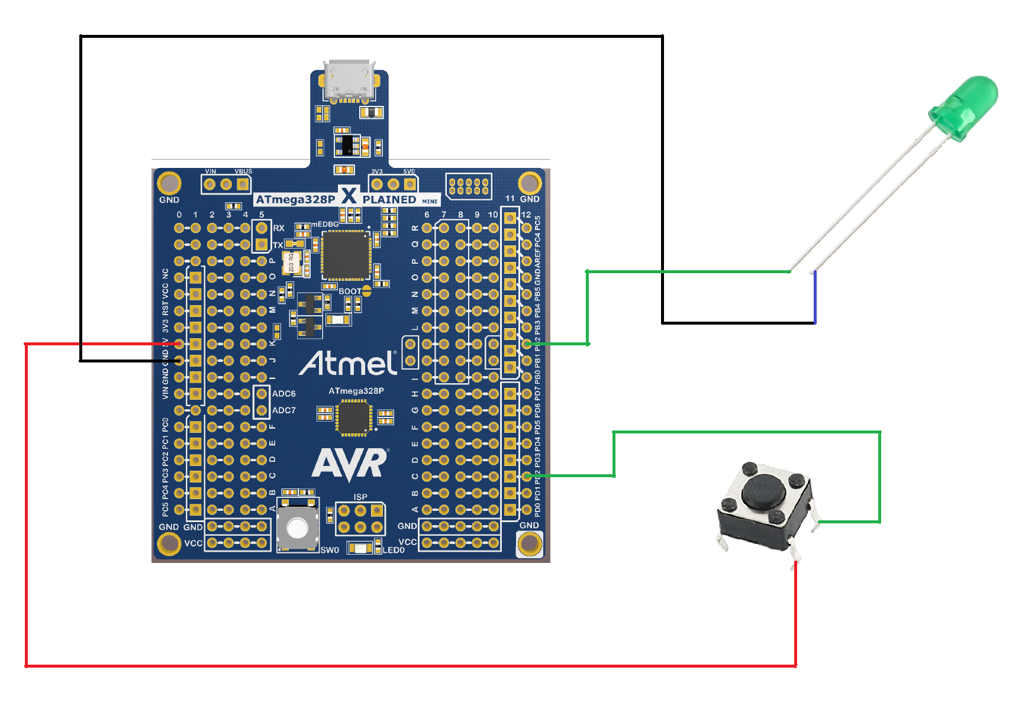

1. **SCREENSHOTS OF EACH TASK OUTPUT (ATMEL STUDIO OUTPUT)**

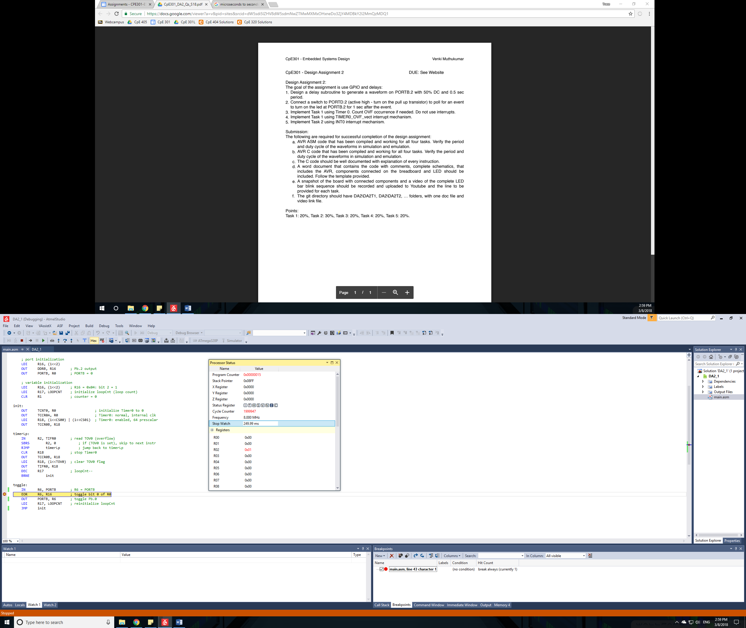

Figure 1 Half a cycle of Task 1 Assembly Code. 0.25 Seconds

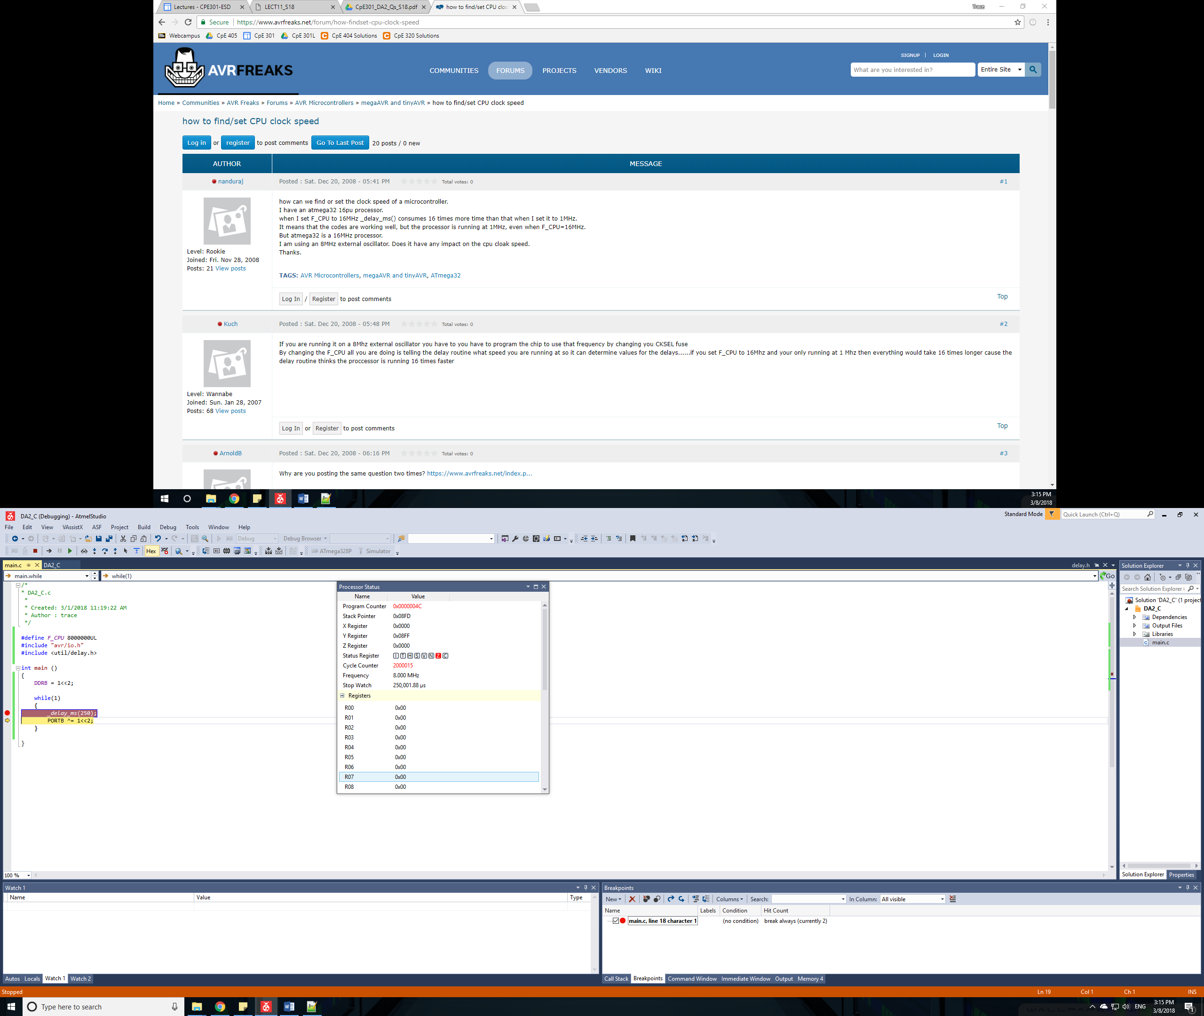

Figure 2: Half a cycle of Task 1 C Code. 0.25 Seconds

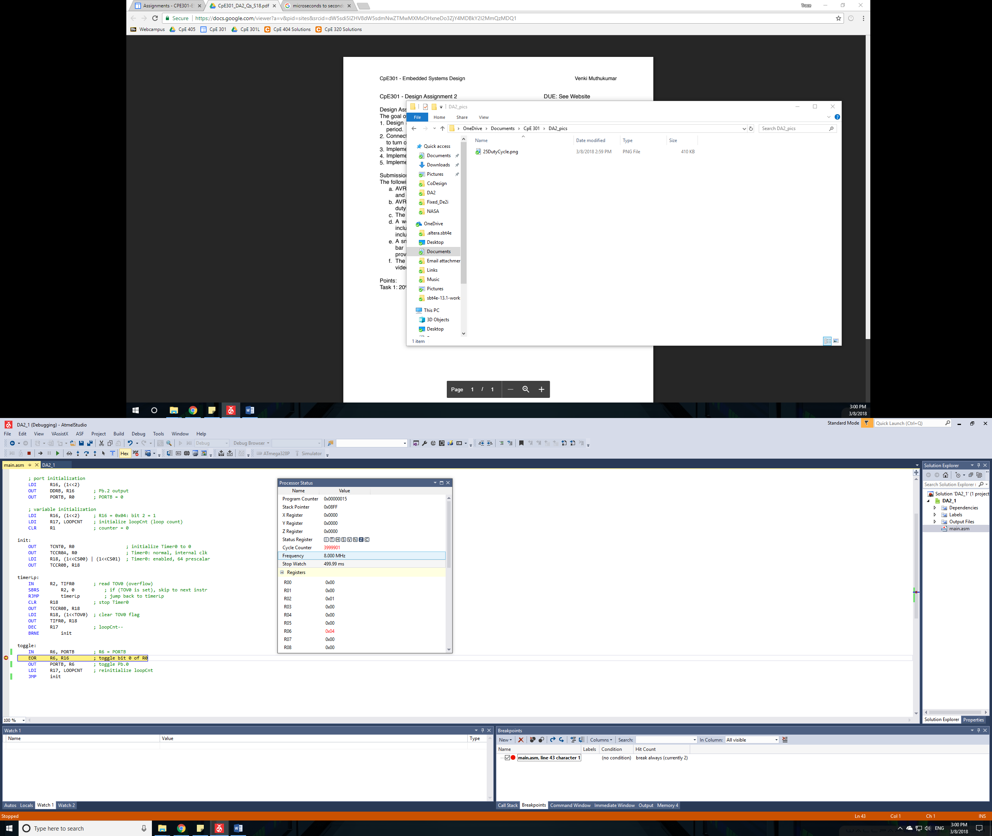

Figure 3: Full cycle of task 1, Assembly Code. 0.5 Seconds

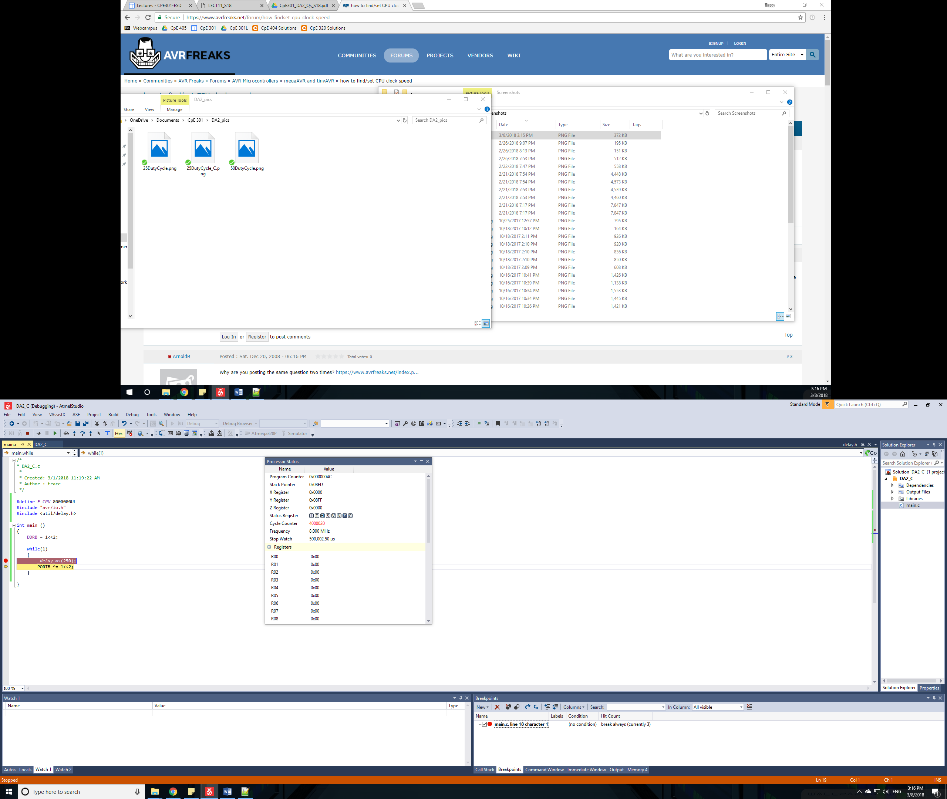

Figure 4: Full cycle of task 1, C Code. 0.5 Seconds

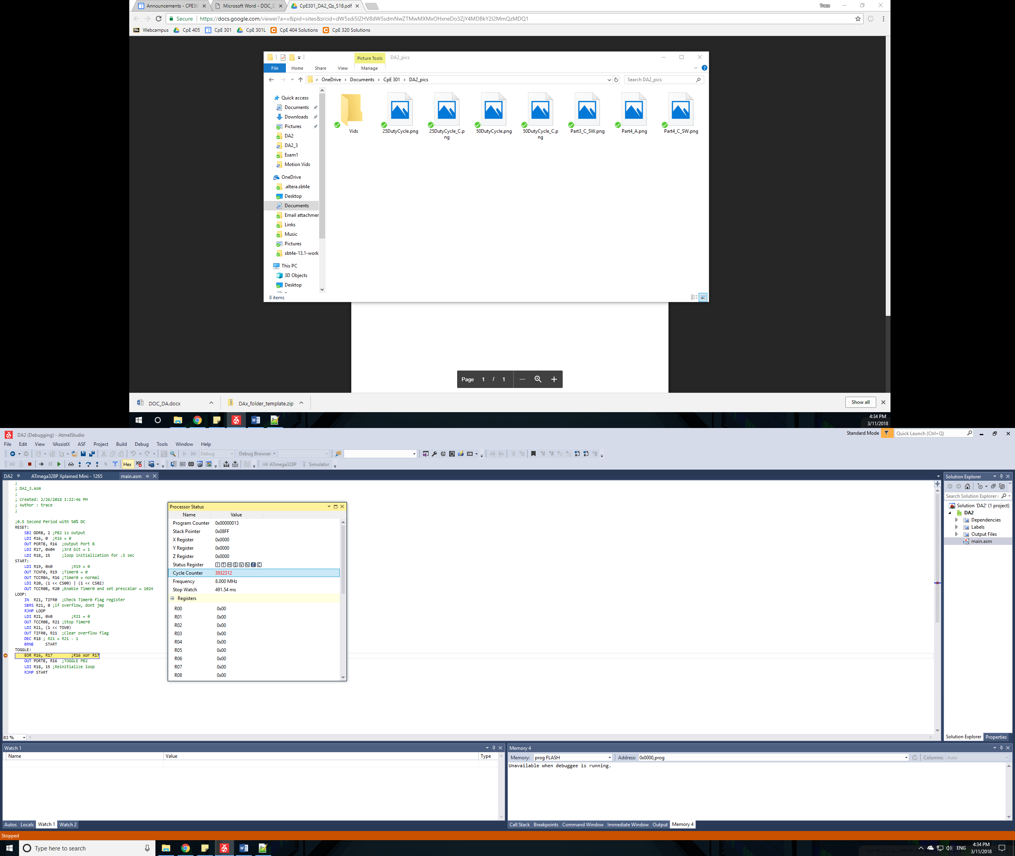

Figure 5: Full Cycle of Task 3 Assembly Code. 0.5 Seconds.

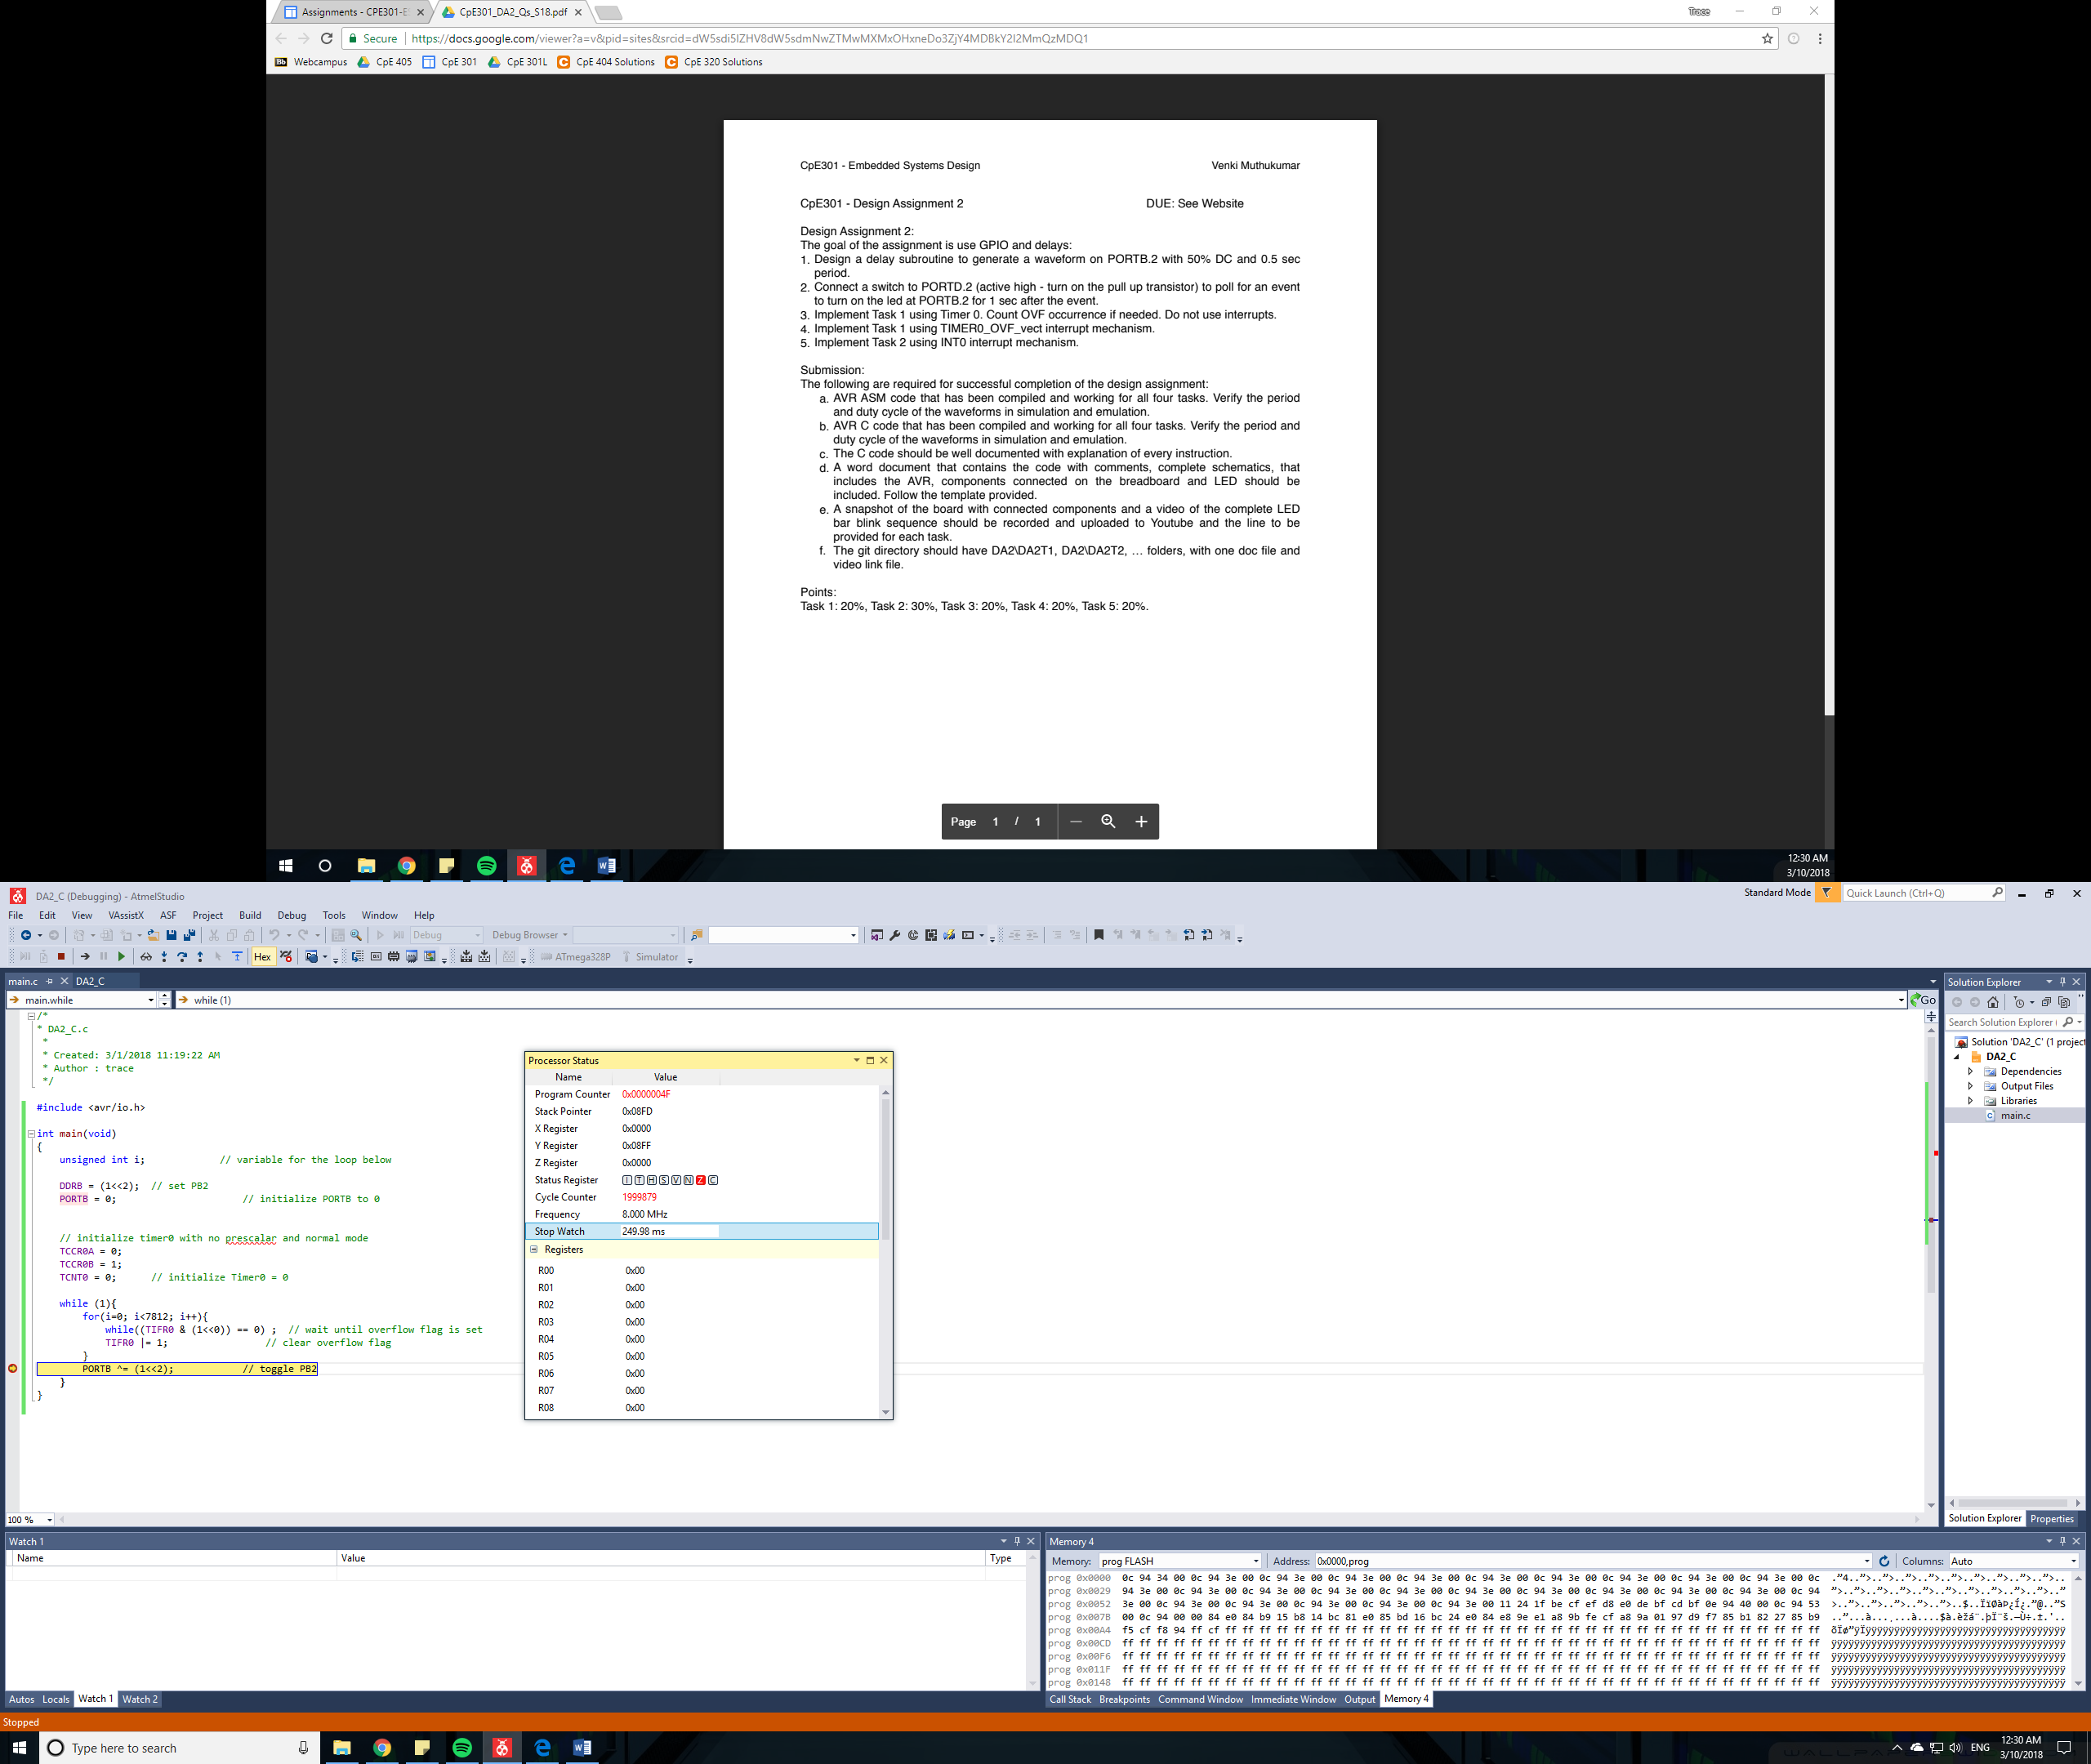

Figure 6: Half Cycle of Task 3 C code. 0.25 Seconds

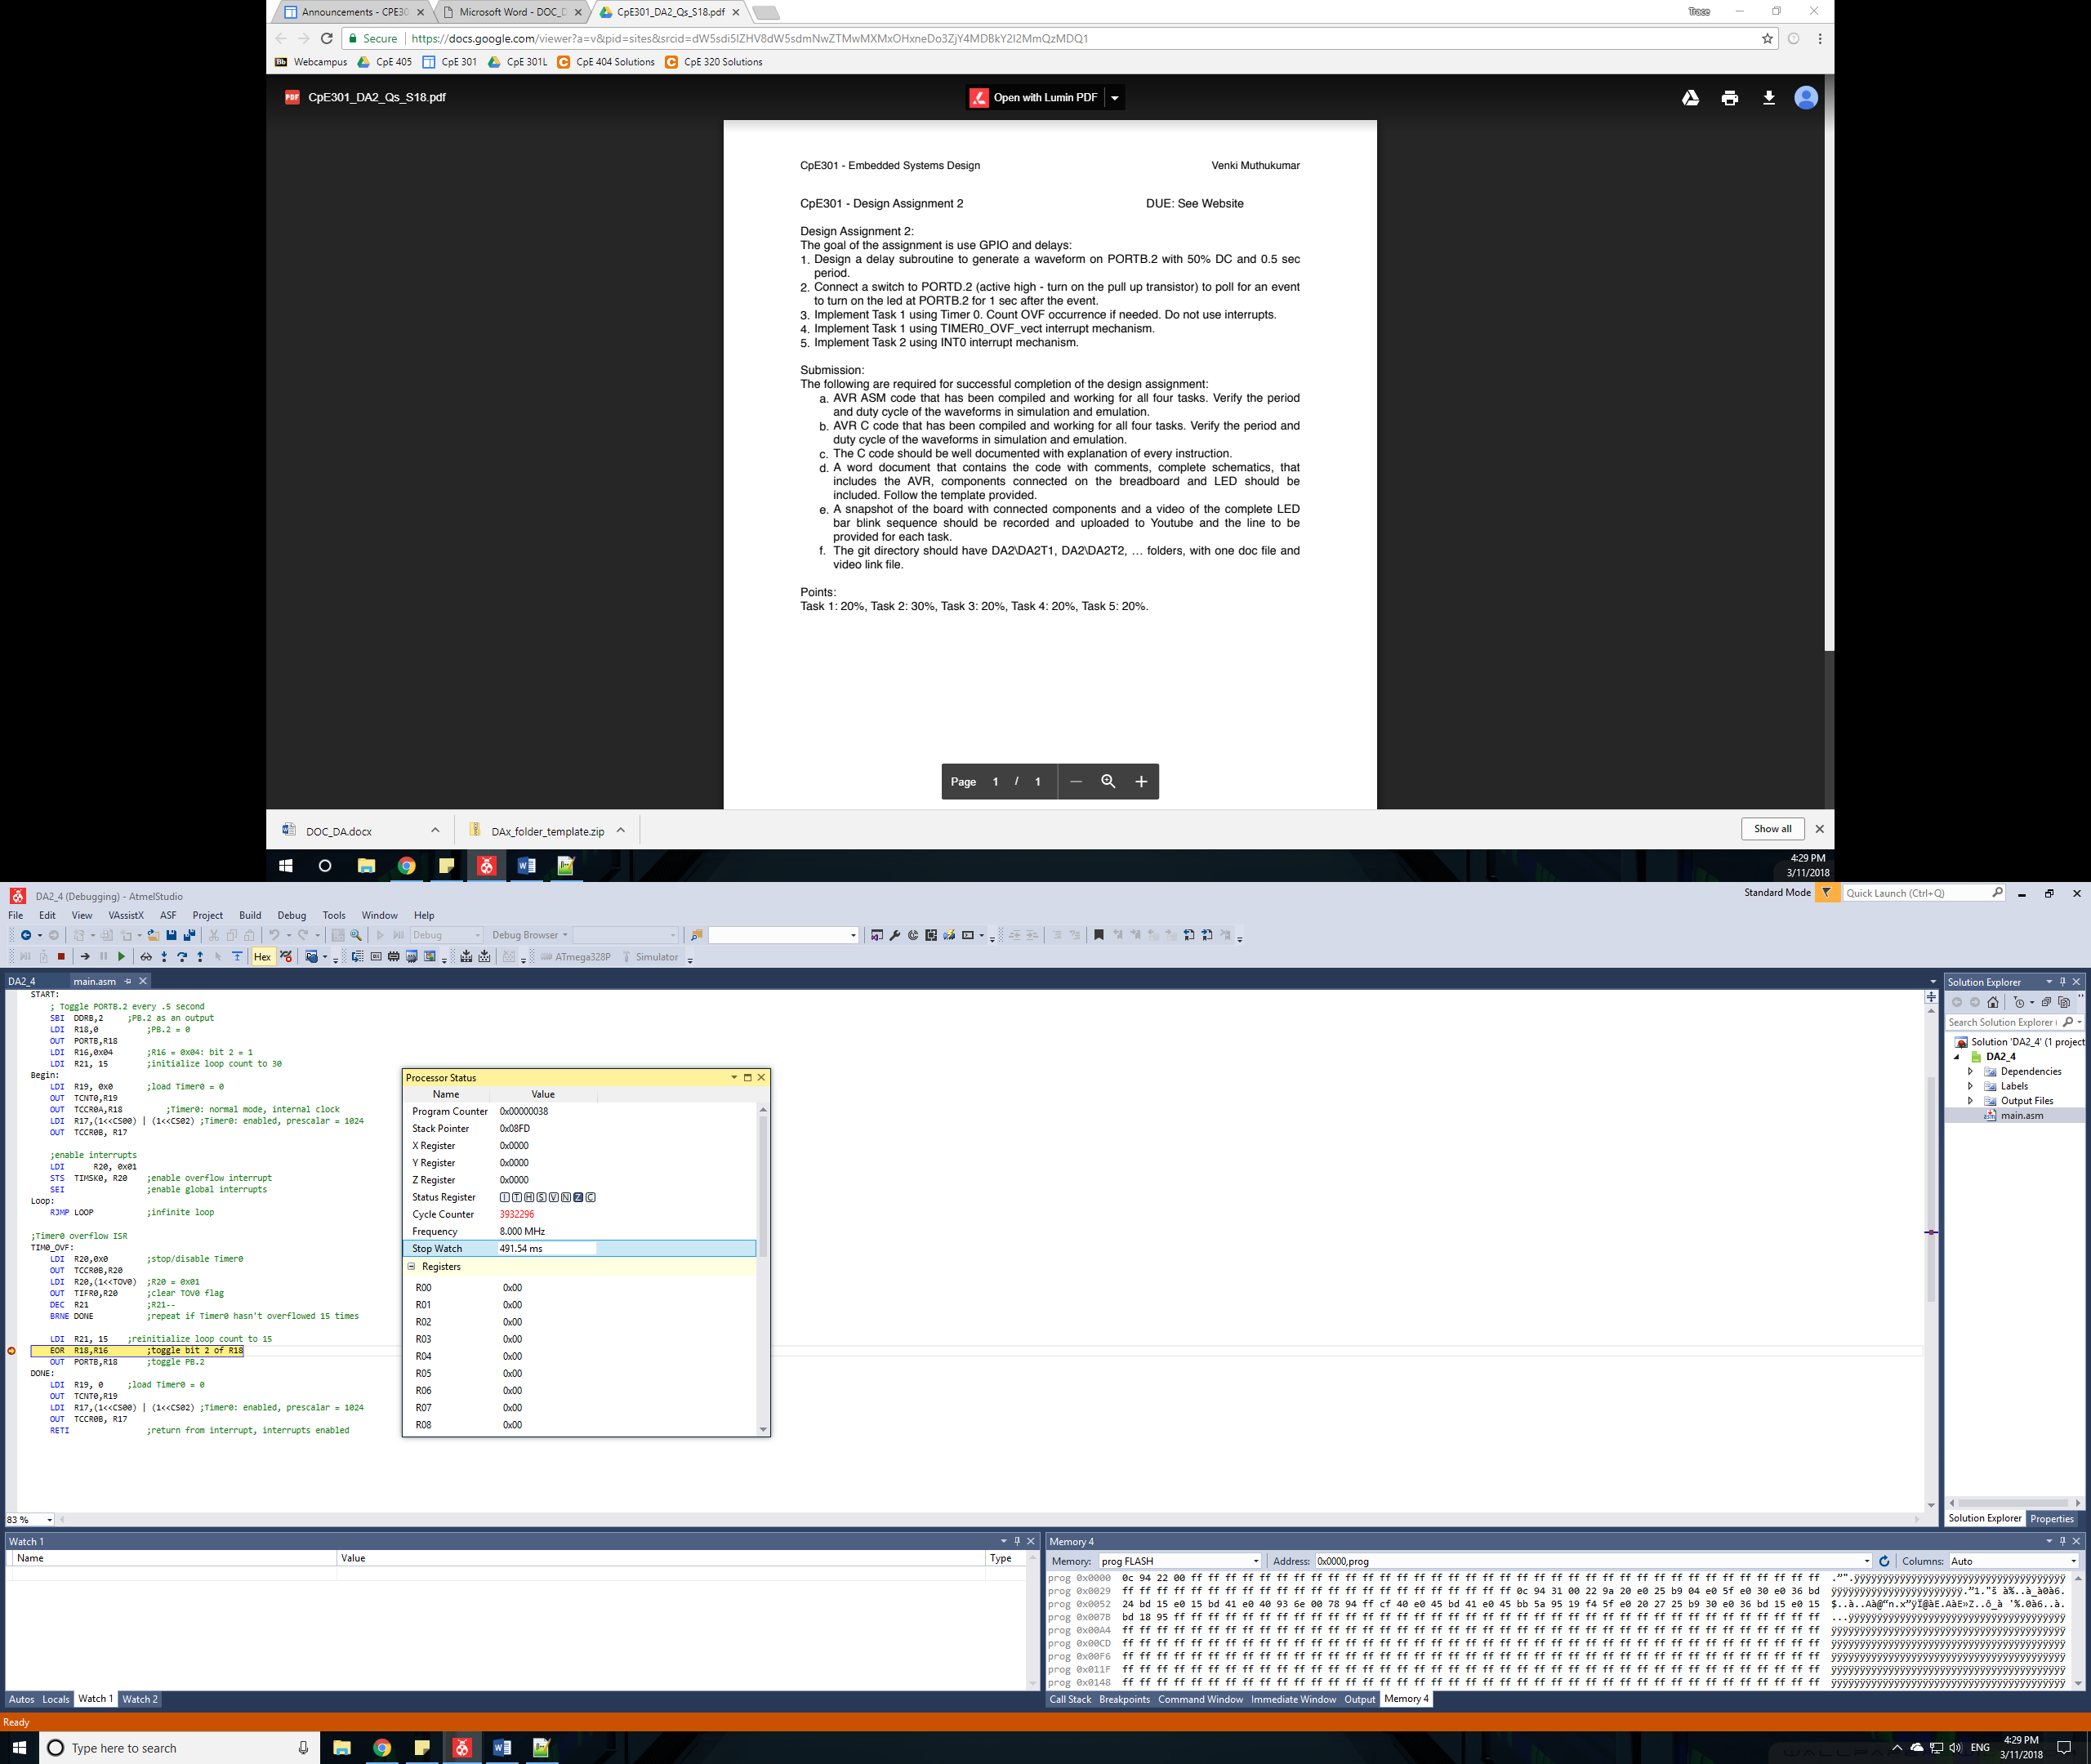

Figure 7: Full Cycle of Task 4 Assembly Code. 0.5 Seconds

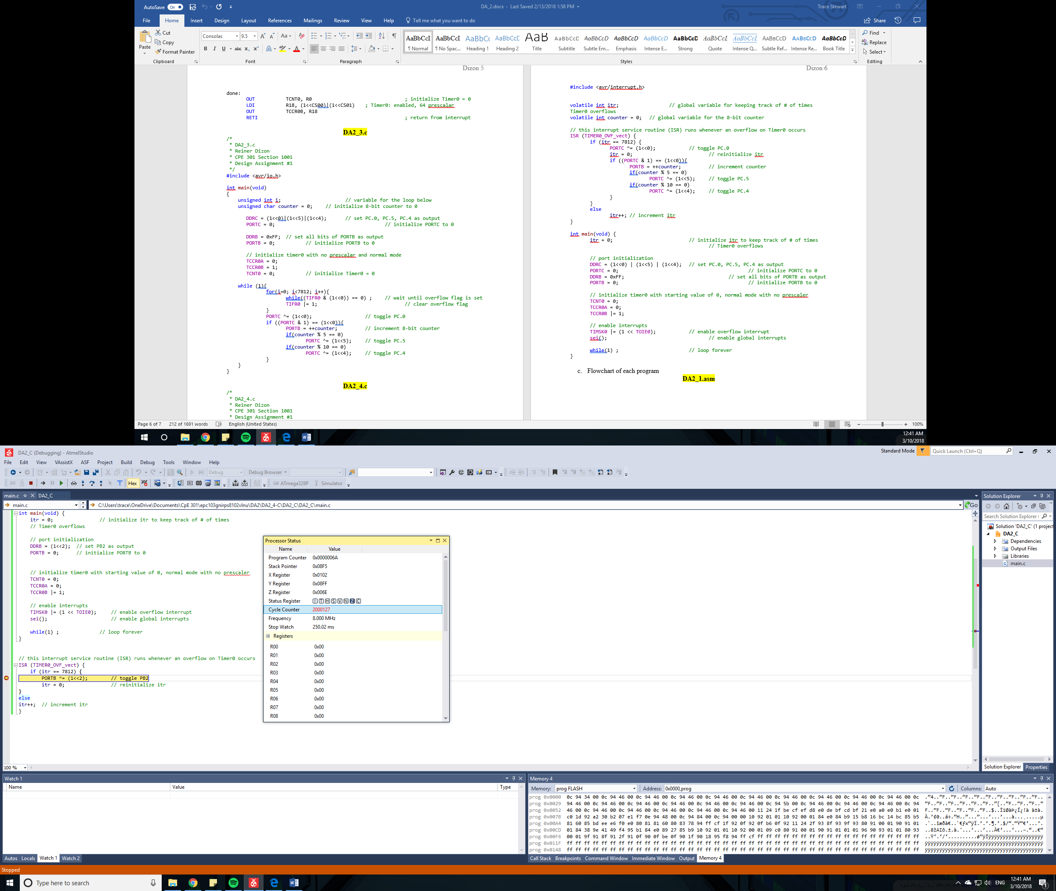

Figure 8: Half cycle of Task 4 C Code. 0.25 Seconds

1. **SCREENSHOT OF EACH DEMO (BOARD SETUP)**

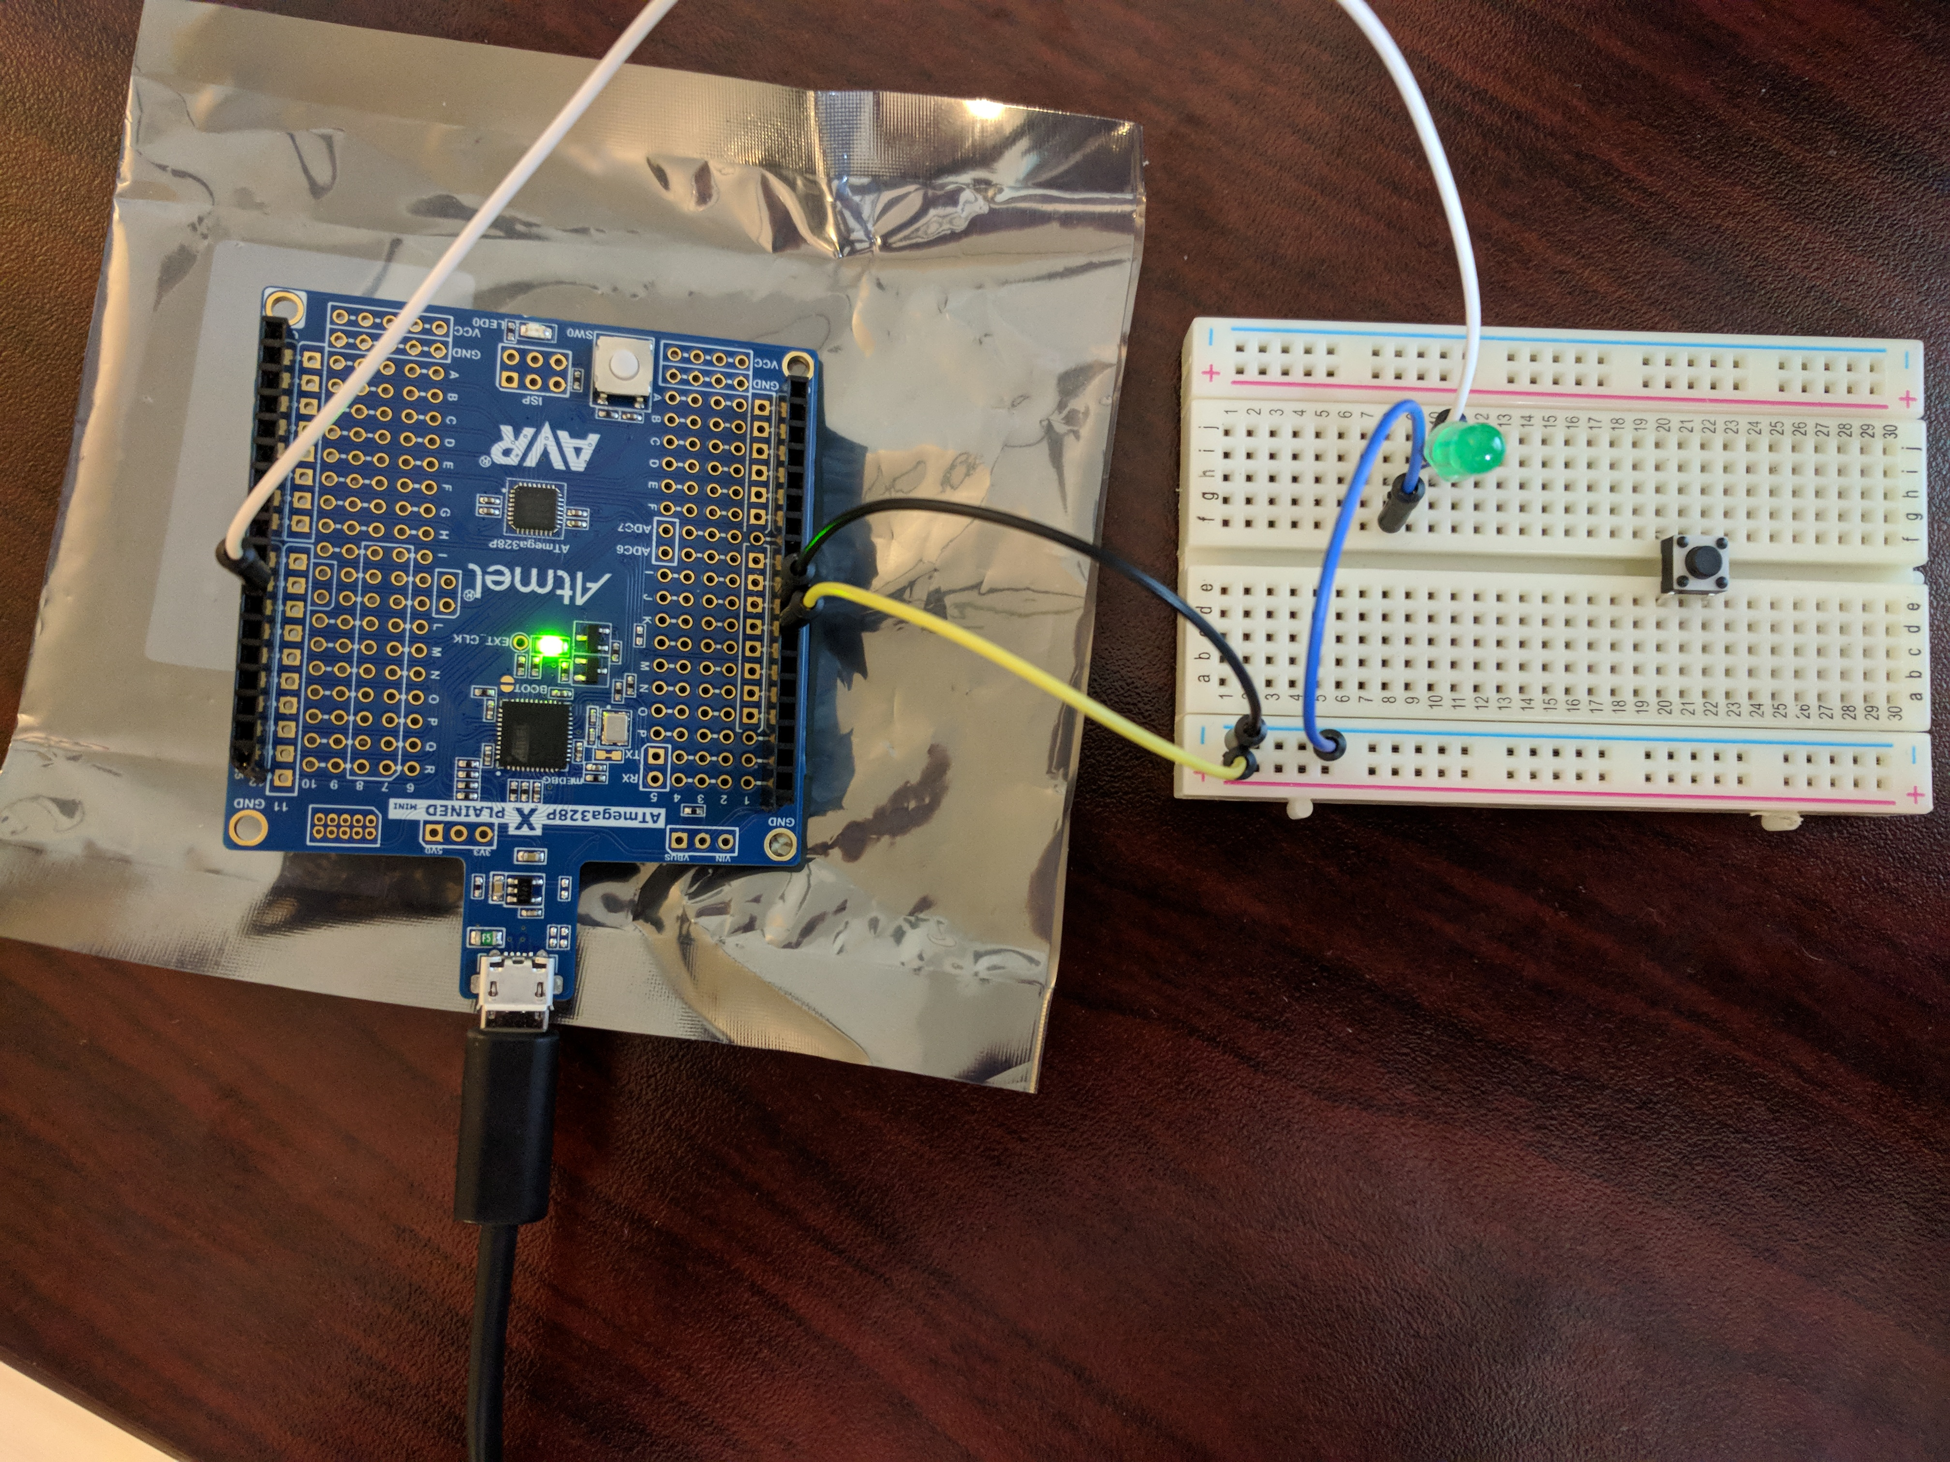

Figure 9: Board Setup for Task 1, Task 3, and Task 4

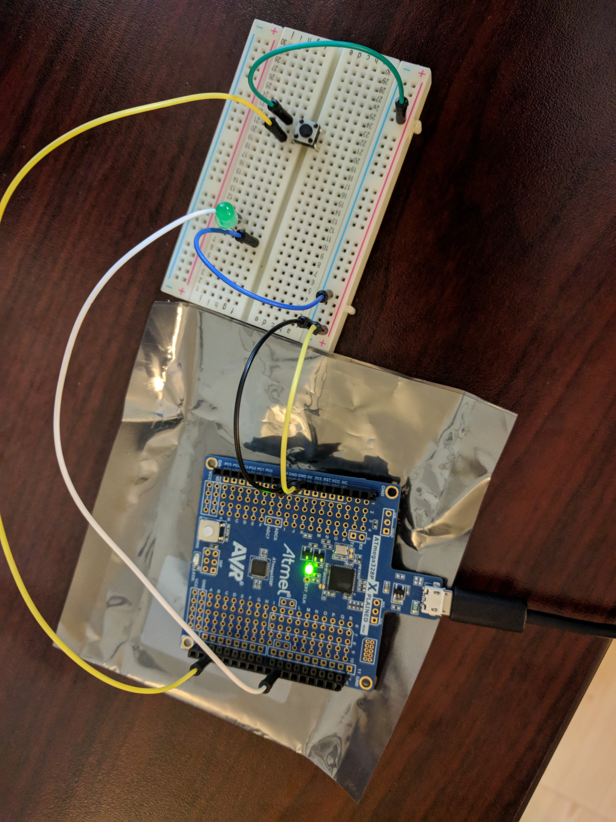

Figure 10: Board setup for Task 2 and Task 5

1. **VIDEO LINKS OF EACH DEMO**

Task 1 Assembly: https://www.youtube.com/watch?v=DoauVUG7VW8

Task 1 C: https://www.youtube.com/watch?v=ve6Gr7Gz-vQ

Task 2 Assembly: https://www.youtube.com/watch?v=KDIGaYRWjEc

Task 2 C: https://www.youtube.com/watch?v=A-hojAG77uE

Task 3 Assembly: https://www.youtube.com/watch?v=-HLhe0F6zU8

Task 3 C: https://www.youtube.com/watch?v=boD4b2jlvZ8

Task 4 Assembly: https://www.youtube.com/watch?v=FhFOzb6HhTY

Task 4 C: https://www.youtube.com/watch?v=CXvC9ACjI4Q

Task 5 Assembly: https://www.youtube.com/watch?v=-aQgYOmq2vc

Task 5 C: https://www.youtube.com/watch?v=5_HqqGo9MB4

1. **GITHUB LINK OF THIS DA**

https://github.com/TraceStewart/epc103gnirps8102vlnu/tree/master/DA2

**Student Academic Misconduct Policy**

<http://studentconduct.unlv.edu/misconduct/policy.html>

“This assignment submission is my own, original work”.

Trace Stewart